**Sexual dimorphic blue bands are intra-sexual aposematic signal in the male pond damselfly**

Md Kawsar Khan1*, Marie E. Herberstein1

1. Department of Biological Science, Macquarie University, NSW-2109, Australia

**Author of correspondence:**

Md Kawsar Khan

Department of Biological Science

Macquarie University, Sydney

NSW-2109, Australia

Email: [Kawsar.khan@mq.edu.au](mailto:Kawsar.khan@mq.edu.au)

Phone: +612-9850-6279

Key words: warning signal, sexual conflict, ornamental colouration, visual modelling

Abstract

1. Sexually dimorphic traits in males are thought to evolve via female preference. However, in species without overt male displays or female mate choice, dimorphic colouration may function as a warning signal to conspecific males thereby avoiding costly harassment. We aim to determine the function of sexual dimorphic coloration in *Xanthagrion erythroneurum* damselflies where males, but not females carry conspicuous blue bands on the tip of the abdomen.
2. The male blue bands and female black abdomen are chromatically and achromatically discriminable both in damselfly visual system. In the natural habitat of damselfly, the male blue bands generate higher chromatic contrast than female abdominal coloration.
3. We abolished male blue bands by painting black over blue and measured the female preferences between the manipulated and the control males. We did not find any difference in mating success between the control and manipulated male thereby rejected the female preference hypothesis for the function of blue bands in this damselfly.
4. To test whether the blue bands function as a warning signal, we manipulated the females by painting male-like blue bands on their abdominal segments and measured the male reaction to those females relative to control females. Females with artificial blue bands on the terminal abdomen were mated with less frequently than control females. However, when we painted blue bands on the anterior abdominal segments the males did not discriminate between control and painted females.
5. We conclude that the blue bands in the male damselflies are not an inter-sexual signal to attract females rather function as an aposematic signal towards other males to avoid intra-sexual harassment.

Introduction:

According to the sexual selection theory, conspicuous male colouration in animals can evolve if they improve attractiveness to females or increase success in male-male competition or both (Darwin, 1888). One striking example of conspicuous male colouration is the sexual dimorphic colouration, also known as ornamental colouration. In such cases, males exhibit their ornamental colouration during courtship display and females prefer mating with more conspicuous males. The sexual dimorphic male colouration is often associated with male qualities such as better physiological conditions (body mass (Contreras-Garduño, Buzatto, Serrano-Meneses, Nájera-Cordero, & Córdoba-Aguilar, 2008), body size (Serrano-Meneses, Córdoba-Aguilar, Méndez, Layen, & Székely, 2007), immunity(Córdoba-Aguilar, 2002), and sperm quality (Fukuda & Karino, 2014)), better territory defending capabilities (Córdoba-Aguilar, 2002) and higher social status (Bergman, Ho, & Beehner, 2009). On the other hand, in many species where males do not exhibit courtship displays, male-limited dimorphic colouration can still evolve as an intra-sexual signal irrespective of female preferences. Conspicuous dimorphic male colouration can display male fitness to avoid the cost of unnecessary fights (Olsson, 1994) or unprofitability as a mate-partner to avoid unwanted mating encounter from other males (Beatty, Andrés, & Sherratt, 2015).

Sexual dimorphic blue bands are commonly found in many damselflies of the Coenagrionidae family. In these damselflies, males neither maintain territories, nor do they perform courtship displays (Corbet, 1999). The mate searching males hover around the breeding ponds looking for a mating partner, and the scenario resembles a scramble competition among males. After encountering a female, the male approaches from behind and grasps the female from above to form a tandem. As a consequences of that the females cannot see the colour of an approaching male. Moreover, the males can coerce a female to mate even when it is unwilling. As a consequences of that, the females do not have a choice over whether or not they mate or with whom, making inter-sexual selection an unlikely mechanism to drive male-limited colour dimorphism. Sherratt and Forbes (2001) proposed that conspicuous male colouration in these damselflies is not a signal to females, rather it is a warning signal to other males to avoid costly mating harassment (Sherrat & Forbes, 2001). In a scramble mating competition erroneous male-male mating occurrence is not uncommon. In this circumstance, male-limited conspicuous colouration can evolve to display their unprofitability as a mate to conspecific males.

Fincke (1997), however, argued that females can show mating unwillingness and avoid tandem formation by hiding themselves, by flying away, by death feigning, by abdomen curling and by wing raise signal (Fincke, 1997). Moreover, even after a tandem formation a male needs female’s cooperation for bending her abdomen to form wheel to receive the sperm. Female can show resistance in this stage by delaying wheel formation or even by dissociating from the wheel. In the presence of such strong female choice, a female might be able to reject the unwanted males. In this circumstance, sexual dimorphic ornamental colouration can evolve from female preferences. Although intriguing female preferences for male colouration is yet to be tested in damselflies.

In *Xanthagrion erythroneurum* damselfly, adult males have two blue bands on the dorsum of abdominal segments 8 and 9, (S8 and S9) whereas the female does not have these bands (Figure 1a-b). We aim to determine the function of the male-limited blue bands in this damselfly by experimentally testing both the sexual selection hypothesis and the antiharassment aposematic hypothesis. If the male specific blue bands evolved through female preferences, we predict that mating success of a male with blue bands will be higher than the success of a male without them. On the other hand, if blue bands function as an intrasexual aposematic signal, the presence of the blue bands will drive off the mating desire of an approaching male. The best way to experimentally validate this hypothesis is to paint the blue bands on female’s abdomen and observe the mating decision of the approaching males. We predict that the presence of the blue bands will repel males and thus females bearing blue bands will be avoided, even though males are able to recognize females based on other female cues.

Materials and Methods

Study species

The *Xanthagrion erythoneurum* commonly known as Red and blue damselflyis a medium size damselfly (19–21 mm) of the Coenagrionidae family (Zygoptera: Odonata). This species is widely distributed across all Australian states and commonly found in ponds, marshes and dams (Theischinger & Hawking, 2006). The adult male can be easily distinguished from the other Coenagrionidae species by the red face, red thorax, red two and a half abdominal segments, and by the blue bands in abdominal segments eight and nine (Figure 1a) (Theischinger & Hawking, 2006). The females are similar to males, however, their abdomen is dorsally black without any blue band (Figure 1b). In the Sydney region, this species can be seen in flight from September to April and their reproductive season lasts throughout this whole period (Peer observation).

We collected adult male and female *X. erythroneurum* damselflies using an insect sweeping net from the lake situated in the North Ryde campus of Macquarie University, NSW, Australia. Permission was not required to collect this damselfly species because this species is not protected in Australia and studies were conducted outside of any national park or protected area.

Reflectance spectra

We measured the reflectance spectra of the abdominal blue bands of the males from the segments S8 and S9 and the black colouration of the females in the same segments with a Jazz Ocean optics spectrophotometer (Ocean optics, USA). We set the spectrophotometer at an integration time of 20 milliseconds with an average of five successive scans. We used a PX-2 pulse xenon light source and took the measurements relative to a white standard WS-1. We immobilized the damselflies by restraining in a refrigerator at 40C for five minutes before taking the spectra. We focused the light source of the spectrophotometer perpendicular to the cuticular surface of the damselflies and measured spectra from a uniform distance of 2mm. We used a black velvet cloth to block light between the probe and the specimen. We measured spectra of the plant leaves from the pond site where the damselflies usually perch to quantify the background spectrum. We measured reflectance spectra of the damselflies and background leaves between 300nm to 700nm averaged from three measurements.

Discriminability

We used a discriminability index (D) to estimate the chromatic discriminability (Ds) of the dorsal coloration of eighth and ninth abdominal segments of the damselflies (blue in male and black in female) against the natural background based on the index proposed by Hastad et al. (Hastad, Victorsson, & Ödeen, 2005):

where is the average of the chromatic distance of each damselfly spectrum to the measured background spectra and is the average chromatic distance between each background leaf sample. We used a similar rationale for calculating achromatic discriminability (DL) based on the quantum catches of the green photoreceptor since bees and other insects use this photoreceptor to detect achromatic contrast (Giurfa, Vorobyev, Kevan, & Menzel, 1996). The discriminability values (chromatic and achromatic) indicate whether the blue bands of the males or black abdomens of the females are detectable against the natural background ─ a value above zero indicates the signal is visible. Because it is unclear if this species has a tri- or a tetrachromatic visual system, we calculated the discriminability for both and applied unpaired t-tests to compare the chromatic and achromatic discriminability between the sexes.

Female preference experiments

We manipulated the colour of the damselflies using non-toxic colour paint (Tim and Tess poster paint). We used black paint (105 carbon black) to hide the blue bands of the male abdomen. For the control males we applied the black paint in the dorsal side of abdominal segment S7. We kept one manipulated and one control male with two females in an insect mating cage (58cm × 32cm × 34cm). We placed the cage close to a natural lake, in the sunlight and observed their sexual interaction from a distance of approximate to one meter. We calculated the number of the tandem and wheel formation of control and manipulated males. In case when a tandem did not form into a wheel, we calculated the duration of the tandem before the pair dissociated. We also recorded the time taken to attain the wheel from the tandem and the duration of the wheel. A trial was considered successful when a male formed a tandem with a female. If a tandem did not formed within 30 minutes, we recorded it as an unsuccessful trial. The experiment was continued until we reached sixty successful trials. Further analysis were done based on the successful trials. We applied chi-square test to compare reproductive success between the control and manipulated males.

Male choice experiments

We manipulated female colour using non-toxic colour paint (Tim and Tess poster paint). We used 90 peacock blue and 105 carbon black paint for colouring blue and black respectively. We painted two blue bands on females matching the colour and brightness of the males (Figure 1c). In two separate experiments, we varied the position of the bands ─ in the first, the blue bands were applied in the same position as on the male (segments S8 and S9) but in the second experiment we painted the blue bands on segment S4. To control for the paint, we applied black paint over the natural black patches on the control females.

We placed four damselflies (two males, one control female and one manipulated female) into an insect mating cage (58cm × 32cm × 34cm) at the edge of a pond and observed their behavioral interactions. We terminated a trial if a male successfully formed a tandem with a female or after 20 minutes if no tandem occurred. For each experiment, we performed 40 successful trials between 10 am and 4 pm when mating usually occurs in the field. We applied a chi-square test to compare the frequency of tandem pairs in each experiment.

Results

Damselfly spectra

The reflectance spectra of the male blue abdominal bands peaked between 450 and 481 nm while the female abdominal segments did not show any peaks but a gradual increase with increasing wavelengths (Figure 1c). Like males, manipulated females bands also showed reflectance peaks in this region (471-472nm) (Figure 1c).

Discriminability

Both male abdominal blue bands and female abdominal colouration were chromatically and achromatically discriminable in the trichromatic damselfly visual system against the natural background (Figure 1d-e). The chromatic discriminability of the male blue bands was significantly (p < 0.001) higher than females abdominal colouration (Figure 1d). However, no significant difference in discriminability was found between the sexes achromatically (Figure 1e). In case of a tetrachromatic visual system, dorsal abdominal coloration of both sexes are discriminable against their background ─ males are chromatically more discriminable (p < 0.001) while females are more discriminable achromatically (p < 0.001) (Figure S1a- b).

Female preference

The natural and manipulated males do not differ significantly in terms of tandem and wheel formation. Similarly, there is no significant difference in tandem duration, the time required from tandem to wheel formation and wheel duration between control males and manipulated males.

Male choice assays

When females carried blue bands on abdominal segments S8 and S9 (similar to male colouration) males significantly (χ2 = 4.900, df= 1, p < 0.05) preferred control females over manipulated females (Figure 2a). However, when the females carried the blue bands on abdominal segment S4, the males formed tandems at the same rate with manipulated and control females (χ2 = 0.400, df= 1, p = 0.527) (Figure 2b). We did not observe any male-male tandem formation.

Discussion

We manipulated the male blue bands and observed the female preference for mating partner between the altered and control males. If the male blue bands are sexually selected ornamental colouration then the male with the blue bands will have sexual success more than the males without blue bands. Our results, however, showed that there were no significant difference in the number of tandems between the control and manipulated males. As males approach from above the female during tandem formation, the females cannot immediately see male colouration and cannot reject an approaching male on the basis of its colouration. One might argue that in a cage experiment a female cannot fly away from an approaching male even if it wants to, and the outcome can be due to females’ movement restriction. A female can still reject a male and dissociate from the tandem, or can delay the wheel formation. We did not, however, find any difference in tandem duration, numbers of wheel formation and the duration of wheel formation between the control and manipulated males. From our knowledge, our study provides the first experimental evidence showing in damselflies the female does not have preference for dimorphic colouration in males. We conclude that, male-limited dimorphic colouration is unlikely to evolve through female preferences.

We also found that when females carried blue abdominal bands in the same position as males, they were less attractive than control females or females that carried blue bands elsewhere on the abdomen. There are two possible interpretations of our observations: either males failed to recognize manipulated females as potential mates or the blue bands act as a warning signal to males. We argue for the latter interpretation as males had sufficient cues available to identify females. Odonates use tactile and visual cues for mate recognition (Winfrey & Fincke, 2017). The female black abdomen is the most important cue for mate recognition (Gorb, 1998). However, males also use body size (Pezalla, 1979), abdomen shape (Gorb, 1998; Ubukata, 1983), flight pattern (Ubukata, 1983), female display (S. Gorb, 1992; Utzeri, 1988), thorax colouration and pattern (Miller & Fincke, 1999; Xu, Cerreta, Schultz, & Fincke, 2014) and chemical cues (Frati, Piersanti, Conti, Rebora, & Salerno, 2015) for mate recognition. Moreover, Gorb (1998) showed that males can even recognize a female based on the part of their whole image or by the presence of isolated female body parts (thorax, head) (Gorb, 1998). Hence, we argue that the males in our study could still identify the manipulated females as a conspecific female based on their overall phenotype. However, the presence of the blue bands on the female’s abdomen repelled males and may thus function as a warning signal, possibly indicating an unprofitable mating partner.

To define the conspicuous colouration that displays unprofitability Poulton (1890) used the term “aposematism” (Poulton, 1890). Later on, “aposematism” was typically used in the context of predator-prey interaction where bright, vivid colouration of a prey signals their unpalatability to predators. However, aposematic signals are not restricted to interspecific communication, neither are the functions limited to predation avoidance. For example, in *Battus phileno* butterflies, the colour pattern of the larva is an intraspecific aposematic signal to repel conspecific females from ovipositing on the same leaves, thereby reducing intraspecific competition (Papaj & Newsom, 2005). In damselflies Sherratt and Forbes applied the concept of aposematism in a sexual context and suggested the term “antisexual aposematism” to explain the function of conspicuous colouration to avoid unwanted sexual harassment. The hypothesis was later supported in the *Nehalennia irene* damselfly, where abdominal blue colouration on males repelled conspecific males (Beatty et al., 2015). Our present finding further solidify this hypothesis by showing that the males avoid mating with females bearing the warning signal even after knowing them as potential mate based on other mate recognition cue.

Our results showed that the spatial location of the aposematic bands is crucial for their function. A visual signal will function most effectively when presented properly to the receiver and thus often evolve to the particular body pars to maximize its presentation. The aposematic coloration of the unpalatable poison dart frogs are located on their dorsal body parts which maximizes its presentation to their predator birds (Dreher, Cummings, & Pröhl, 2015; Maan & Cummings, 2011). Similarly aposematic bands evolve on the upper wings of the butterfly to maximize the color presentation when it flies (Joshi, Prakash, & Kunte, 2017; Su, Lim, & Kunte, 2015). In our study damselfly, the painted blue bands on the female’s abdomen were effective to repel males only when present on the dorsal side of the terminal abdominal segments. Considering the mating biology of damselflies where males approach from behind and grab females from the top to form a tandem, an aposematic signal will function most effectively if presented on the distal end of the dorsal body side. This spatial position also maximizes the presentation of the blue bands during the threat display where a male raise its tail to threatened conspecific males (Utzeri, 1988).

An aposematic colour pattern function best when the signal generate high contrast against background and when the pattern possesses high internal contrast (Endler, Krebs, & Davies, 1991; Stevens & Ruxton, 2012). In *Xanthagrion erythroneurum* damselfly, warning signal comprises two blue bands separated by black abdominal coluration. The combination of black with bright color such as red, yellow, blue generate high internal contrast and considered as classic aposematic colour (Cott, 1940). The blue colour of damselflies, further generates high chromatic and achromatic contrast against a natural green background (Figure 1 d; Schultz, Anderson, & Symes, 2008). High colour contrast signals enhance speed and stability of avoidance learning and reduce recognition errors (Gamberale-Stille, 2001).

Aposematism benefits both the signaler and the receiver. Male-male interactions can be costly in terms of time, energy and fitness. In *Ischnura ramburii* damselfly male-male mating interactions decrease males survival and lower body mass (Gering, 2017). In *X. erythroneurum*, the warning signal can helps males to avoid male-male tandem formation and thus can be beneficial for both of the receiver and approaching male. Further studies are needed to understand the cost of the dimorphic bands to males in terms of color production and predation cost they possesses due to presence of those conspicuous bands. The abdominal blue bands in males are commonly found in many damselfly species ( Peer observation, see also Beatty et al., 2015; S. N. Gorb, 1998) and thus our findings raise the tantalizing question whether blue abdominal bands function as an aposematic signal across many odonatan taxa.

References:

Figure 1: Photograph of a male and (b) a female *X. erythroneurum* (c) Aggregated reflectance spectra (mean ± SD) of the males blue bands (N= 20, red line), females abdominal colouration (N = 14, green line), painted blue bands on the manipulated females (N= 8, blue line) and background plant leaves (N= 31, purple line) (d) Chromatic discriminability (Ds) and (e) Achromatic discriminability (DL) of male and female abdominal (S8-S9) colouration in the trichromatic damselfly visual system.

Figure 2: (a) Number of tandems formed by the control and the manipulated males (b) Number of wheels formed by the control and the manipulated males (c) Duration in tandem formation between the control males and the manipulated males (d) Time required to form wheel from the tandem between the control males and the manipulated males (e) Duration in wheel formation between the control males and the manipulated males. (ns= not significant).

Figure 3:

(a) The number of control females and S8 and S9 manipulated females (blue bands on segments S8 and S9) and (b) the number of control females and S4 manipulated females (blue bands on segment S4) recorded in mating pairs during the mate choice experiment (n = 40, * p<0.05).

Figure 1:

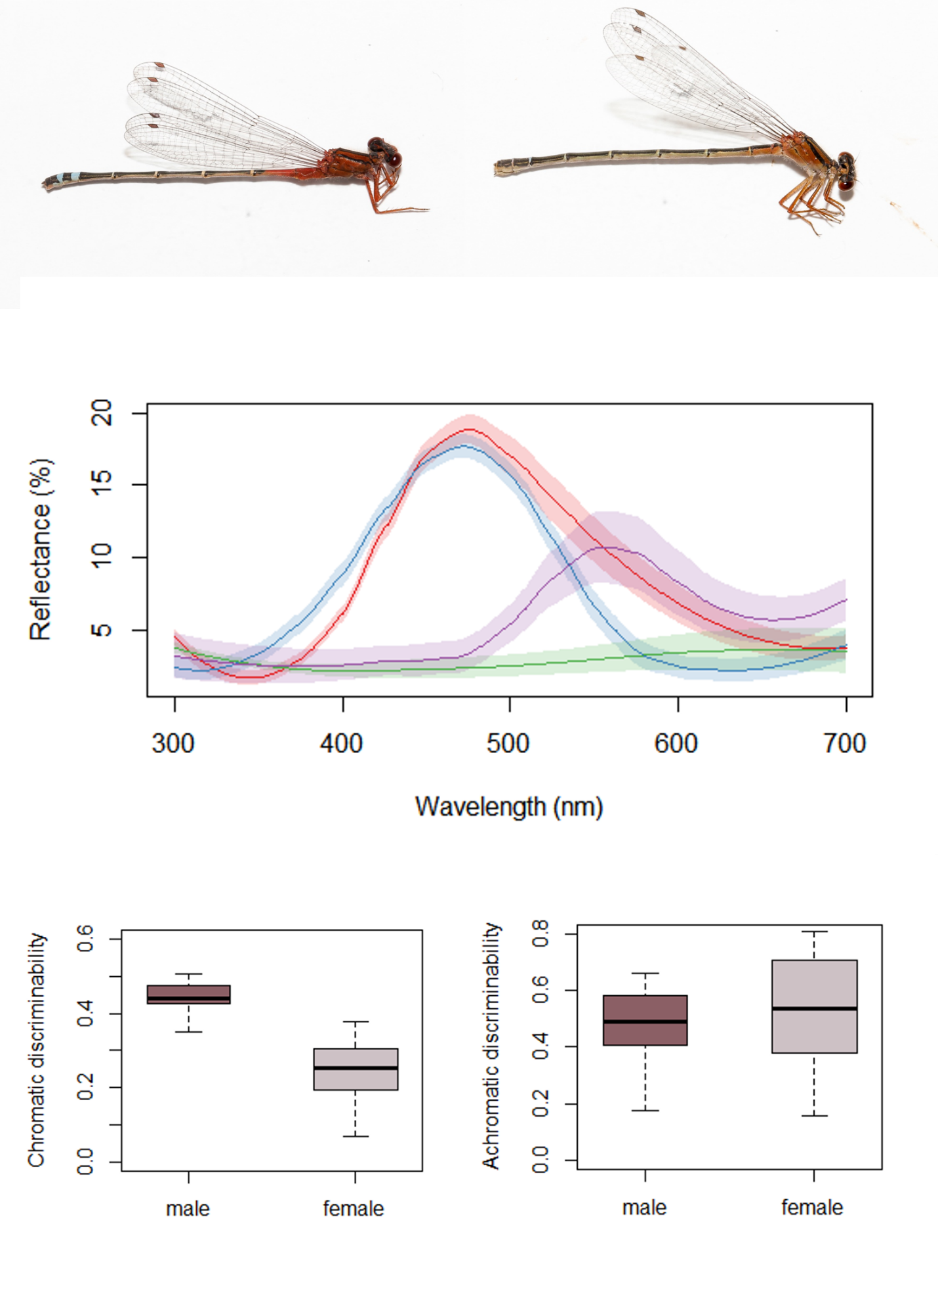

Figure 2:

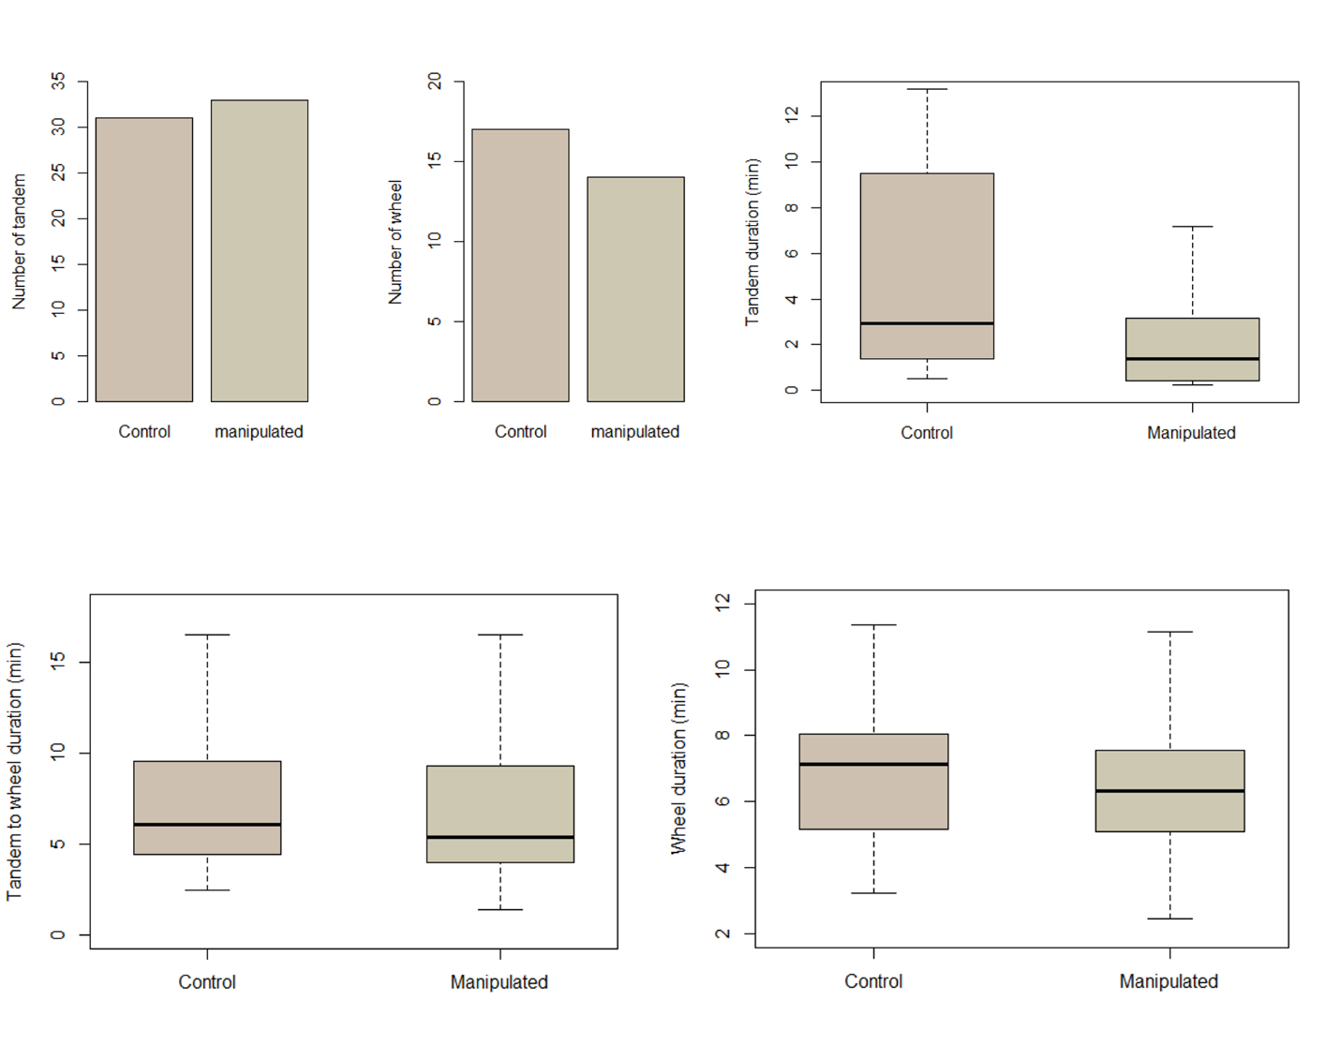

Figure 3:

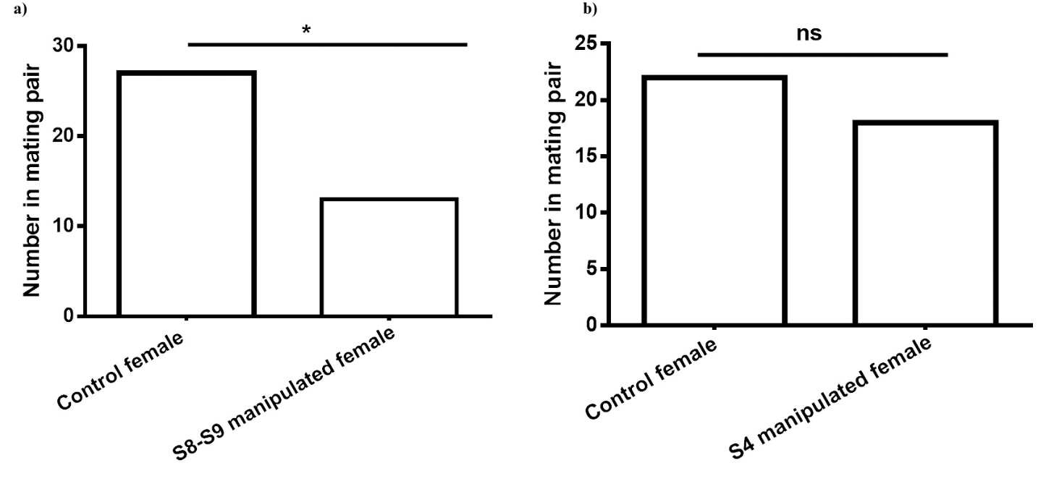

**References:**

Beatty, C. D., Andrés, J. A., & Sherratt, T. N. (2015). Conspicuous Coloration in Males of the Damselfly Nehalennia irene (Zygoptera: Coenagrionidae): Do Males Signal Their Unprofitability to Other Males? *PLOS ONE*, *10*(11), e0142684. https://doi.org/10.1371/journal.pone.0142684

Bergman, T. J., Ho, L., & Beehner, J. C. (2009). Chest Color and Social Status in Male Geladas (<Emphasis Type="Italic">Theropithecus gelada</Emphasis>). *International Journal of Primatology*, *30*(6), 791–806. https://doi.org/10.1007/s10764-009-9374-x

Contreras-Garduño, J., Buzatto, B. A., Serrano-Meneses, M. A., Nájera-Cordero, K., & Córdoba-Aguilar, A. (2008). The size of the red wing spot of the American rubyspot as a heightened condition-dependent ornament. *Behavioral Ecology*, *19*(4), 724–732. https://doi.org/10.1093/beheco/arn026

Corbet, P. S. (1999). *Dragonflies: Behaviour and Ecology of Odonata*. New York: Cornell University Press.

Córdoba-Aguilar, A. (2002). Wing pigmentation in territorial male damselflies, Calopteryx haemorrhoidalis: a possible relation to sexual selection. *Animal Behaviour*, *63*(4), 759–766. https://doi.org/10.1006/anbe.2001.1974

Cott, H. B. (1940). *Adaptive coloration in animals*. Methuen; London.

Darwin, C. (1888). *The descent of man and selection in relation to sex* (Vol. 1). Murray.

Dreher, C. E., Cummings, M. E., & Pröhl, H. (2015). An Analysis of Predator Selection to Affect Aposematic Coloration in a Poison Frog Species. *PLOS ONE*, *10*(6), e0130571. https://doi.org/10.1371/journal.pone.0130571

Endler, B. E., Krebs, J. R., & Davies, N. (1991). Interactions between predators and prey. *Behavioural Ecology: An Evolutionary Approach.*, 169–202.

Fincke, O. M. (1997). Conflict resolution in the Odonata: implications for understanding female mating patterns and female choice. *Biological Journal of the Linnean Society*, *60*(2), 201–220.

Frati, F., Piersanti, S., Conti, E., Rebora, M., & Salerno, G. (2015). Scent of a dragonfly: sex recognition in a polymorphic coenagrionid. *PloS One*, *10*(8), e0136697.

Fukuda, S., & Karino, K. (2014). Male red coloration, female mate preference, and sperm longevity in the cyprinid fish Puntius titteya. *Environmental Biology of Fishes*, *97*(11), 1197–1205.

Gamberale-Stille, G. (2001). Benefit by contrast: an experiment with live aposematic prey. *Behavioral Ecology*, *12*(6), 768–772.

Gering, E. J. (2017). Male‐mimicking females increase male‐male interactions, and decrease male survival and condition in a female‐polymorphic damselfly. *Evolution*, *71*(5), 1390–1396. https://doi.org/10.1111/evo.13221

Giurfa, M., Vorobyev, M., Kevan, P., & Menzel, R. (1996). Detection of coloured stimuli by honeybees: minimum visual angles and receptor specific contrasts. *Journal of Comparative Physiology A*, *178*(5), 699–709.

Gorb, S. (1992). An experimental study of the refusal display in the damselfly Platycnemis pennipes (Pall.)(Zygoptera: Platycnemididae). *Odonatologica*, *21*(3), 299–307.

Gorb, S. N. (1998). Visual cues in mate recognition by males of the damselfly, Coenagrion puella (L.)(Odonata: Coenagrionidae). *Journal of Insect Behavior*, *11*(1), 73–92.

Hastad, O., Victorsson, J., & Ödeen, A. (2005). Differences in color vision make passerines less conspicuous in the eyes of their predators. *Proceedings of the National Academy of Sciences of the United States of America*, *102*(18), 6391–6394.

Joshi, J., Prakash, A., & Kunte, K. (2017). Evolutionary Assembly of Communities in Butterfly Mimicry Rings. *The American Naturalist*, *189*(4), E58–E76. https://doi.org/10.1086/690907

Maan, M. E., & Cummings, M. E. (2011). Poison frog colors are honest signals of toxicity, particularly for bird predators. *The American Naturalist*, *179*(1), E1–E14.

Miller, M. N., & Fincke, O. M. (1999). Cues for mate recognition and the effect of prior experience on mate recognition in Enallagma damselflies. *Journal of Insect Behavior*, *12*(6), 801–814.

Olsson, M. (1994). Nuptial coloration in the sand lizard, Lacerta agilis: an intra-sexually selected cue to lighting ability. *Animal Behaviour*, *48*(3), 607–613. https://doi.org/10.1006/anbe.1994.1280

Papaj, D. R., & Newsom, G. M. (2005). A within-species warning function for an aposematic signal. *Proceedings of the Royal Society of London B: Biological Sciences*, *272*(1580), 2519–2523.

Pezalla, V. M. (1979). Behavioral ecology of the dragonfly Libellula pulchella Drury (Odonata: Anisoptera). *American Midland Naturalist*, 1–22.

Poulton, E. B. (1890). *The colours of animals: their meaning and use, especially considered in the case of insects*. D. Appleton.

Schultz, T. D., Anderson, C. N., & Symes, L. B. (2008). The conspicuousness of colour cues in male pond damselflies depends on ambient light and visual system. *Animal Behaviour*, *76*(4), 1357–1364.

Serrano-Meneses, M. A., Córdoba-Aguilar, A., Méndez, V., Layen, S. J., & Székely, T. (2007). Sexual size dimorphism in the American rubyspot: male body size predicts male competition and mating success. *Animal Behaviour*, *73*(6), 987–997. https://doi.org/10.1016/j.anbehav.2006.08.012

Sherrat, T. N., & Forbes, M. R. (2001). Sexual differences in coloration of Coenagrionid damselflies (Odonata): a case of intraspecific aposematism. *Anim. Behav*, *62*, 653–660.

Stevens, M., & Ruxton, G. D. (2012). Linking the evolution and form of warning coloration in nature. *Proc. R. Soc. B*, *279*(1728), 417–426.

Su, S., Lim, M., & Kunte, K. (2015). Prey from the eyes of predators: Color discriminability of aposematic and mimetic butterflies from an avian visual perspective. *Evolution*, *69*(11), 2985–2994. https://doi.org/10.1111/evo.12800

Theischinger, G., & Hawking, J. (2006). *The Complete Field Guide to Dragonflies of Australia*. Csiro Publishing.

Ubukata, H. (1983). An experimental study of sex recognition in Cordulia aenea amurensis Selys (Anisoptera: Corduliidae). *Odonatologica*, *12*(1), 71–81.

Utzeri, C. (1988). Female” refusal display” versus male” threat display” in Zygoptera: is it a case of intraspecific imitation? *Odonatologica*, *17*(1), 45–54.

Winfrey, C., & Fincke, O. M. (2017). Role of visual and non-visual cues in damselfly mate recognition. *International Journal of Odonatology*, *20*(1), 43–52.

Xu, M., Cerreta, A. L., Schultz, T. D., & Fincke, O. M. (2014). Selective use of multiple cues by males reflects a decision rule for sex discrimination in a sexually mimetic damselfly. *Animal Behaviour*, *92*, 9–18.